Perineal Massage

Starting around 34 weeks, try massaging your perineum (the area around your vagina). Daily perineal massage may increase the area's ability to stretch, leading to less need for an episiotomy and fewer natural tears.
Try this technique yourself, with clean hands and trimmed nails, or have your partner do it for you. If you're going solo, have a large mirror handy so you can see what you're doing and familiarize yourself with your perineal area.
- Sit in a semi-reclined position in a warm, comfortable area, with your knees bent and your legs apart. Lubricate your fingers, thumbs, and perineal area with vitamin E oil (from punctured vitamin E capsules) or personal lubricant. Don't use baby oil, mineral oil, or petroleum jelly.
- Place your thumbs about 1 to 1 1/2 inches (to or just past your first knuckle) inside your vagina. Press down toward the rectum and toward the sides at the same time. Gently and firmly continue stretching until you feel a slight burn or tingling.
- Try holding this stretch for about two minutes.
- Slowly and gently massage the lower part of the vagina back and forth, hooking your thumbs onto the sides of your vagina and gently pulling the tissue forward, as your baby's head will do during delivery. Try keeping this up for at least three to four minutes.
- Finally, massage the tissue between the thumb and forefinger back and forth for about a minute.
- Most important thing is to be gentle -- a vigorous touch could cause bruising or swelling. During the massage, avoid pressure on the urethra (urinary opening) as this can lead to irritation or infection.
Of course, perineal massage isn't for everyone and it may not help in every case.

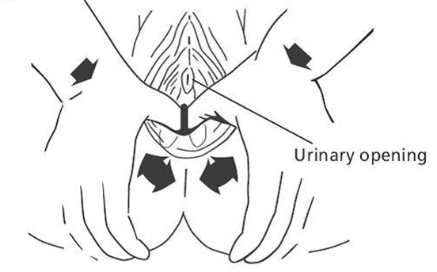

Karla Dickmeyer, MD / Ashley Durward, MD / Kate Sample, MD / Erin Schoenecker, MD / Shafaali Sharma, MD
Mary Stoffel, MD / Beth Wiedel, MD / Sarah Yanke, MD/ Leslie Smith, CNM / Stephanie Brasser, APNP

